**Project URL:** <https://github.com/imran40/QA-Automation-Framework.git>

**Project Files:**

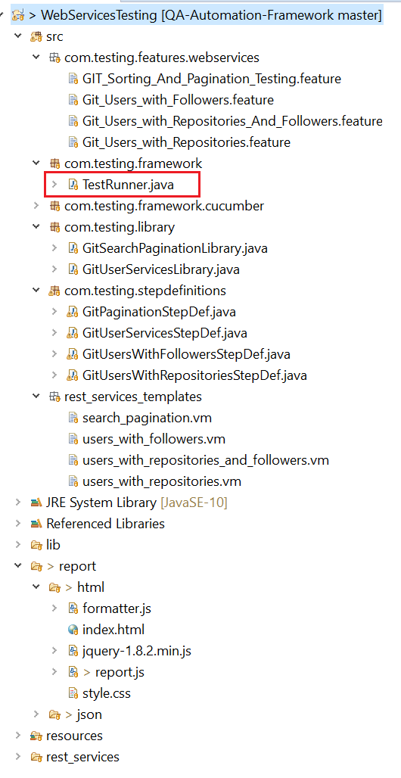

TestRunner: This class has main method that can be used to run the test.

.feature files: Theses files have test cases with annotations.

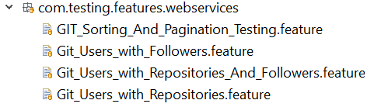

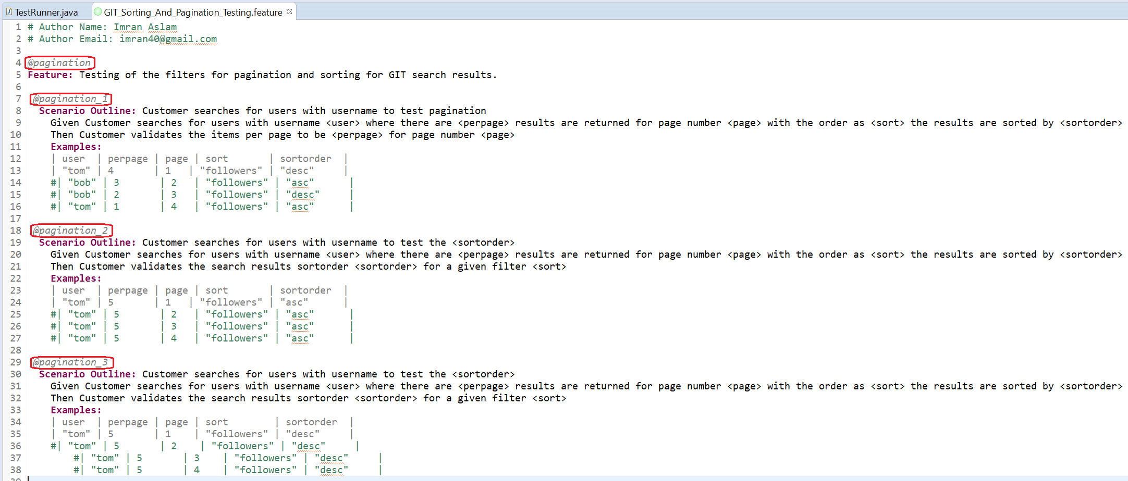

The annotations on test cases can be used to run the test in the following manner:

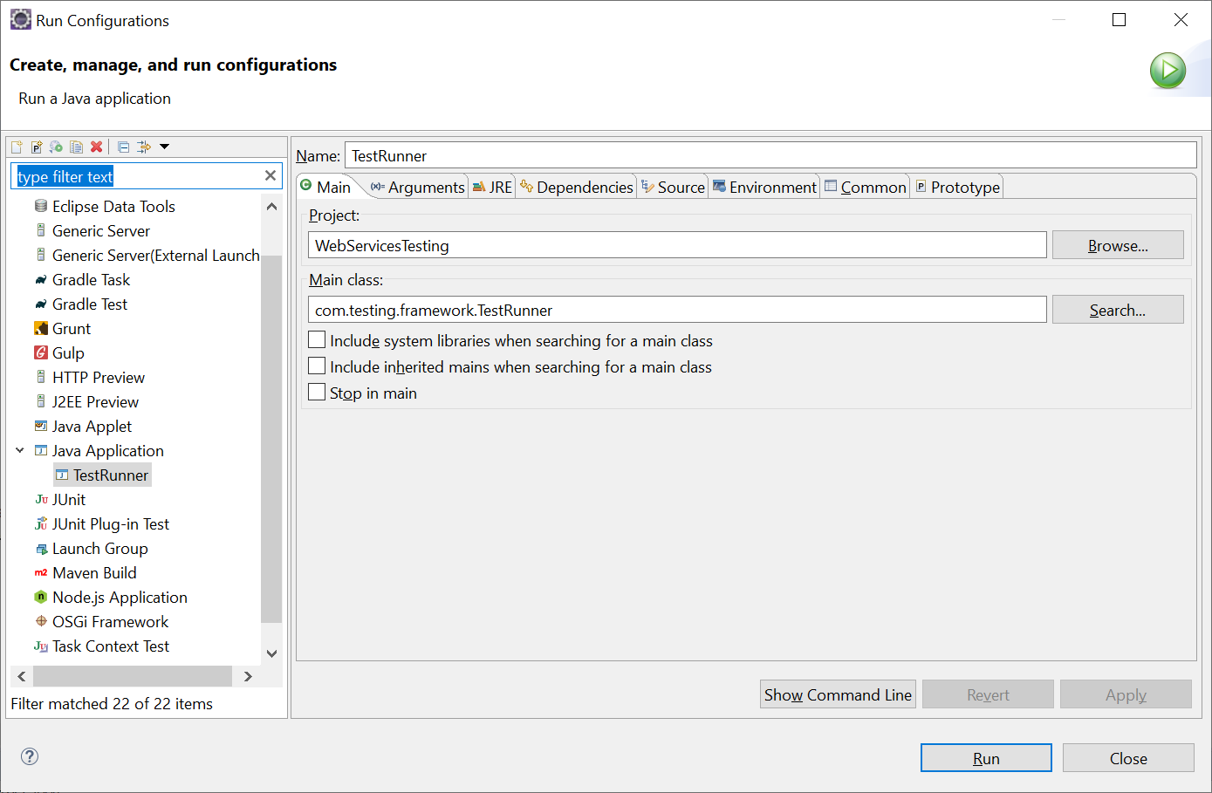

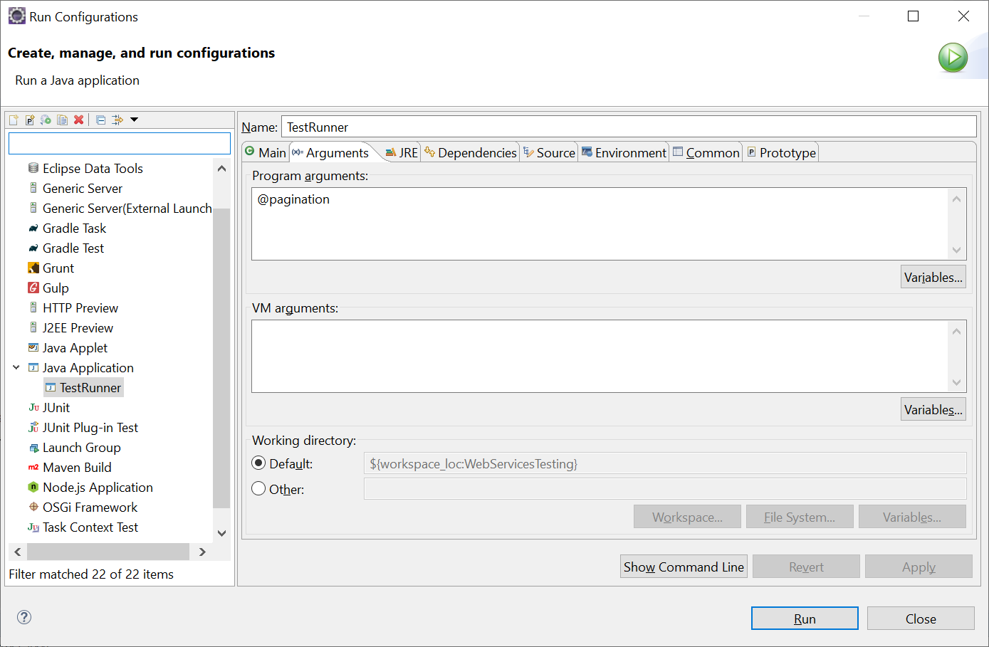

**Step Definitions:** This has the glue code for the steps that are in feature files

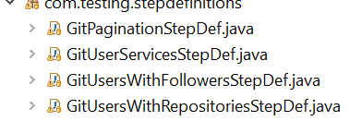

.**VM Files:** These files have service requests templates. The dynamic values in these templates are getting injected from the step data to form a complete http request.

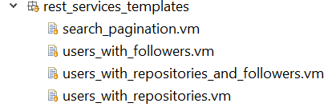

**Report:** Report can be viewed by opening index.html in the browser:

